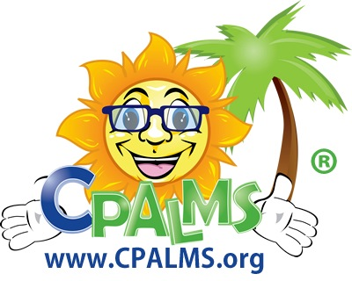
CPALMS Scavenger Hunt: K-5 Math Edition
Finding Standards Information and Teaching Resources
FCR-STEM and FLDOE, together in partnership with school districts, consortia, and universities throughout Florida, have built an online system to provide Florida educators with the most up-to-date information about the Common Core State Standards (CCSS) and Florida’s Next Generation Sunshine State Standards (NGSSS). CPALMS also provides course descriptions and standards-aligned teaching resources. These information systems can be accessed at www.cpalms.org

The purpose of this scavenger hunt is to familiarize you with the information and tools available at www.cpalms.org. We recommend this activity be completed first by individuals and then discussed in a group.

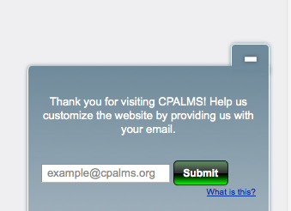
- Connect to the Internet and navigate to www.cpalms.org

- Create your iCPALMS account…
- Return to the CPALMS Homepage

Locating Standards Information

The Browse Method
The Browse method is best for those who might not be familiar with the structure of the CCSS Math and may be looking by subject and grade.

- Click the “Standards Info & Resources” tab on the main menu bar.
- Under the blue “Browse” tab, select CCSS Mathematics from the dropdown menu. As you progress, take notice that each selection you make will immediately filter the standards, as you are searching. How many CCSS Math standards are there? __________
- Select Grade 1 from the drop down menu. How many CCSS Math Grade 1 standards are there? ______
- Select the “Operations and Algebraic Thinking” domain. How many CCSS Math Grade 1 Operations and Algebraic Thinking standards are there? _________
- How many “clusters” are there for this domain? _________
- Select Cluster 3. How many standards are in this cluster?_____

Complete the diagram below to identify what each part of the standards code represents

“OA” represents

“MACC” represents

“5” represents

MACC.1.OA.3.5

“1” represents

“3” represents

- How many resources are aligned to this standard? ___________________

- Challenge: Select “Grade: K12” from the Grade Level drop-down menu. What type of standards are displayed when K12 is selected as the Grade Level? _______________________________________________________________________

The Keyword Search Method
Keyword Search functions allow you to flexibly search for standards, especially if you are familiar with the structure of the Common Core math standards.
  - Click “Standards Info & Resources” on the main menu bar.
  - Click the gray “Keyword Search” tab.
  - After the page reloads, type the keyword(s) “count” in the search box and select CCSS Mathematics in the Subject Area(s) section.
  - Narrow your search by selecting grade level: K and click “Submit”.
  - Scroll all the way to the bottom of the page to see related standards.

- Using the Keyword Search method, find all of the CCSS Math standards in grades K-5 that contain the word “area.” How many standards did you find? ______
How many of those are in the domain Geometry? ______

Download & Print Reports
- Use the “Export and Print Documents” tab in the Standards section of CPALMS to download a report of the CCSS: Math standards in Microsoft Word format.

- On the “Export and Print Documents” page, click “Open Print View” of the CCSS Math, which opens as a pop-up window. This online version can easily be searched using your browser’s find feature.

Locating Teaching Resources
CPALMS already has over 300 teaching resources that are aligned to the CCSS Math. One way to locate teaching resources is to search for a particular standard and then to see which resources are aligned.

- Go back to the Standards Information System>Browse CCSS: Mathematics>Select Grade: K

  - Use the drop down menues to select standard MACC.KOA.1.2
  - On the page that opens, click the bar titled “Related Resources” under the “General Information” section to see the available standards.
  - Open “General Information” bar. What is the cognitive complexity of this standard? ______
  - How many Related Resources are there? _________
    - Select the Resource “Making Tens with Catepillars”
    - Summarize the resource in your own words. _____________________________________________________
__________________________________________________________________________________________________________________________________________________________________________________________________
  - Scroll to the bottom of the screen to notice the “Options”. What would you do if you wanted to print this resource? _____________________________________________________________________________________
  - What if you wanted to share this resource with a colleague, without printing? ____________________________________________________________________________________________________________
  - Notice the yellow “Enhance” and “My Notes” bars. You can customize resources to your liking.

- If time permits, choose other resources to explore. Try visiting the “Resource Center” tab.

