Here you will find all of the printable resources you will need for activity one of “UDL: Barriers and Bridges.”

Resources for Activity 1: Print out task cards for each group.

Activity 1: Search and Find

Directions:

- At your table, find a shoulder partner. Each pair should take a picture from the stack and spend one minute discussing any barriers to learning they see in the picture. At the end of the minute, place a post-it note on the back of the card and take one minute to jot down the barriers you and your partner identified. Continue this process until each pair has reviewed all of the pictures. When you receive a card that already has a post-it note on the back, add any barriers not listed and place a checkmark next to those already listed that you and your partner also identified as barriers (8 min.).

- When you receive the card you started with, you and your partner will have six minutes to list ideas/solutions to address the barriers listed on the card using the provided graphic organizer. How can the UDL principles you learned about earlier help address the barriers to learning? If you finish early, switch cards with a different pair and take turns orally brainstorming ideas/solutions to the barriers listed on their card (6 min.).

- When finished, put the materials back into the envelope and put it in the center of the table. Work with your opposite shoulder partner to discuss how a similar activity would or would not support the learners listed on slide 14 and how you could use UDL principles to support those learners.

Resources for Activity 1: Print and laminate classroom scenario cards (1 set of 4 cards per group of 8).
Independent Reading Time

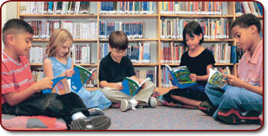

Assessments

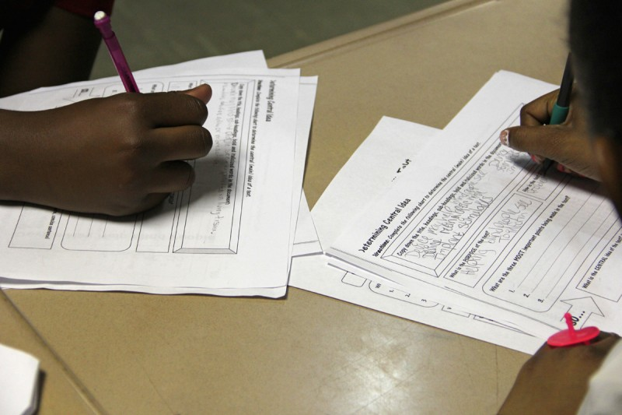
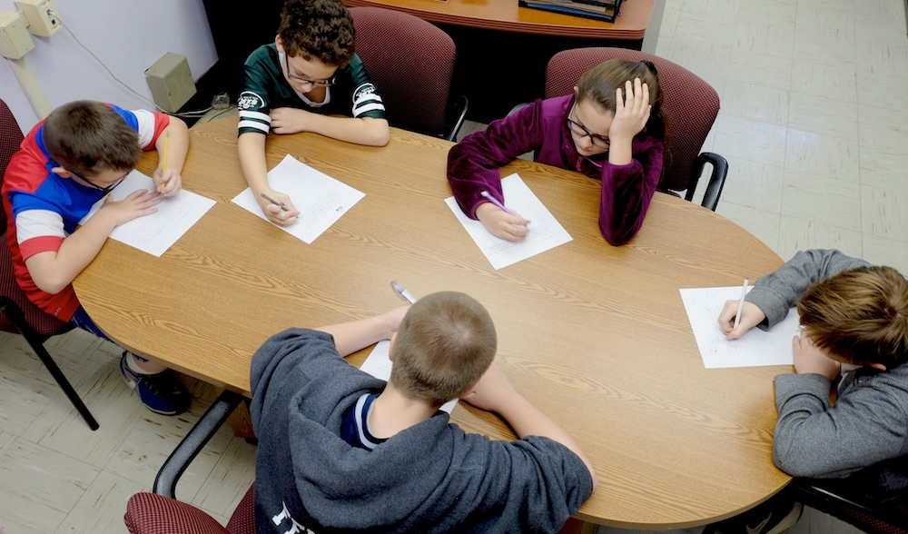
Independent Writing Assignments

Whole Group Instruction
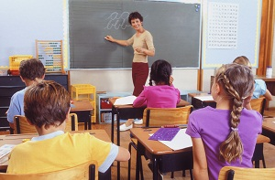
Resources for Activity 1: Print 3 per group of 8 participants (use the modified graphic organizer below for the fourth pair with the participant who has the accommodation card)
Whole Group Instruction
Barrier | Solution
Need more space? Create a copy of the graphic organizer on the back of the paper!

Whole Group Instruction
Barrier | Solution
Need more space? Create a copy of the graphic organizer on the back of the paper!
Resources for Activity 1: Print for use with student pair that includes the participant with the accommodation card.
Whole Group Instruction
Barrier | Solution
All students are taught the same lesson: Many students have already mastered the material being taught.

All students are taught the same lesson: There are some students who do not have the pre-requisite skills to access and engage in the material being taught.

Tactile and kinesthetic learners are not engaged with the visual and auditory presentation.

A student with an auditory processing disorder will need to hear the lesson repeated as they did not process all of the information being presented.

Whole Group Instruction
Barrier | Solution
All students are taught the same lesson: Many students have already mastered the material being taught.

All students are taught the same lesson: There are some students who do not have the pre-requisite skills to access and engage in the material being taught.

Tactile and kinesthetic learners are not engaged with the visual and auditory presentation.

A student with an auditory processing disorder will need to hear the lesson repeated as they did not process all of the information being presented.

Resources for Activity 1: Print on colored cardstock for use with student pair that includes the participant with the accommodation card. This page contains enough solution cards for 4 groups. Cut out boxes with typed solutions.
Whole Group Instruction
Solution | Solution
- differentiated small group activities that include enrichment opportunities for students who have already mastered the content with options to work on above grade level standards | - differentiated small group activities that include enrichment opportunities for students who have already mastered the content with options to work on above grade level standards
- differentiated small group activities that include opportunities for students to work on foundational skills with a trained professional | - differentiated small group activities that include opportunities for students to work on foundational skills with a trained professional
- the teacher incorporates multi-sensory strategies into whole and small group instruction | - the teacher incorporates multi-sensory strategies into whole and small group instruction
- the teachers has the student record the lesson using a table so the student can go back and listen to the lesson again at a later time | - the teachers has the student record the lesson using a tablet so the student can go back and listen to the lesson again at a later time

Whole Group Instruction
Solution | Solution
- differentiated small group activities that include enrichment opportunities for students who have already mastered the content with options to work on above grade level standards | - differentiated small group activities that include enrichment opportunities for students who have already mastered the content with options to work on above grade level standards
- differentiated small group activities that include opportunities for students to work on foundational skills with a trained professional | - differentiated small group activities that include opportunities for students to work on foundational skills with a trained professional
- the teacher incorporates multi-sensory strategies into whole and small group instruction | - the teacher incorporates multi-sensory strategies into whole and small group instruction
- the teachers has the student record the lesson using a table so the student can go back and listen to the lesson again at a later time | - the teachers has the student record the lesson using a tablet so the student can go back and listen to the lesson again at a later time

