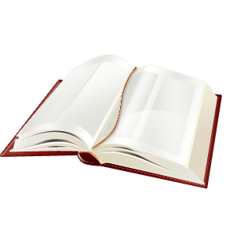
Technology for Student Success: An Introduction
Unit 5 – Accessible Instructional Materials (AIM)
Section 3 – A Bit of Background
History & Copyright
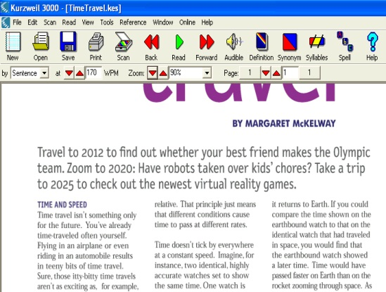
Printed text books and printed materials have been a fundamental part of the educational experience and of the success of educational programs in general. Paper printing offers an easy way to provide consistent materials to a large audience. The same look, feel, and structure have helped to support reliable dissemination and consistency in use. Mass printed materials are generally inexpensive and easy to carry from one place to another.
The strengths of printed materials can also create problems for some students. While the consistent nature of printed materials has resulted in a reliable experience for many students, that same consistency can be difficult to adapt for students with disabilities. Rather than accommodate all students, printed materials exclude some students.
An example of a printed book and a printed book that has been scanned into a computer to create a digital text version.
Throughout the years there have been changes in law to help ensure that all individuals have access to information. In 1931 the “Act of 1931” was passed, authorizing the Library of Congress to establish a national program that provided braille books for adults who were blind. This law helped highlight the fact that all individuals should have equal access to books and information. In 1952 it was revised to include children, and in 1966 it was revised to include adults and children with “physical handicaps.” Finally, in 1974 the Library of Congress established regulations that included individuals with a “reading disability resulting from organic dysfunction.” Even with this addition, the Act of 1931 only addresses the needs of about 1% to 2% of the population of individuals with disabilities.
In 1996, Senator John Chafee (R-R.I.) introduced an amendment to the U.S. Copyright Act that identified “authorized entities” who were exempt from copyright law infringement in the production of specialized formats exclusively for use by “blind or other ‘persons with disabilities.” This amendment, called the “Chafee Amendment,” was based on the Act of 1931 and its’ revisions. With this amendment, these authorized entities are now able to take any printed materials and create copies in formats such as braille, large print, audio, and digital text without violating the copyrights of the authors or the publishers. It is still for a small percentage of individuals with disabilities, but it is a start.
Student Considerations
Natalie currently needs large print and her vision will continue to decline due to Irlin Scoptic Syndrome. She may be eligible for large print materials under the Chafee Amendment.

Jesse has significant reading deficits. A determination will need to be made by a competent authority to see if he has a reading disability resulting from an organic dysfunction.
Pick at least one of the following:
Read
http://www.loc.gov/nls/reference/factsheets/copyright.html
This NLS factsheet provides information on public law 104-197, which is the Chafee Amendment.

Watch
http://www.youtube.com/watch?v=ke6eWXwQIdA
This is a demonstration of how an authorized entity can scan printed text and create a specialized format such as digital text or an audio book.

Explore
http://etc.usf.edu/lit2go/
Lit2Go is a free online collection of stories and poems in audio format, pdf format, and html (web) format. Pick a story and explore the differences between these formats. How could you use them in your classroom?

Section 3 con’t
IDEA & Appropriate and Accessible Instructional Materials
In 2004 the Individuals with Disabilities Education Act (IDEA) introduced language in the law stating that the provision of appropriate and accessible instructional materials in a timely manner is an inherent component of the provision of a free and appropriate public education (FAPE) (34 Code of Federal Regulations [CFR] 300.210(b)(3)). This law specifically addresses students with IEPs, and it is a responsibility of the IEP Team to determine if a student needs accessible instructional materials, the format of such materials, and any related accommodations and assistive technologies needed for the students to participate in and progress in the general curriculum.
Several key terms and phrases were introduced in this legislation. Included are:
Accessible Instructional Materials
Accessible instructional materials are instructional materials and print instructional materials that have been formatted or adapted to meet the individual needs of students with disabilities. Examples include restructured print, braille, large print, digital text (or e-text), audio, graphic-enhanced text, images, and manipulatives.
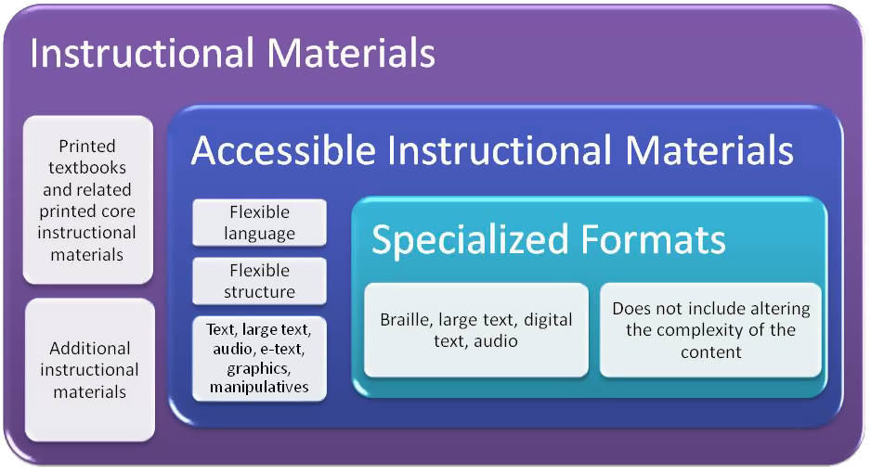
Specialized Formats
Specialized formats (34 CFR §300.172(e)(1)(iv)) are a subset of accessible instructional materials that refer to braille, large print, audio, or digital text used by people who are blind or have other print disabilities. In this context, specialized formats do not include altering the content (e.g., the complexity) of the print instructional material.

Core Instructional Materials (as applied in Florida)
Core instructional materials are printed textbooks and related printed materials published with textbooks that are written and published primarily for use in elementary and secondary school instruction AND are required by the Florida Department of Education or the school district for classroom use. (State-Adopted Instructional Materials).
These materials DO NOT INCLUDE materials that are not written and published primarily for students to use in the classroom (e.g., trade books not bundled with the textbook, newspapers, and reference works) and ancillary or supplemental materials that are not necessary to meet the curriculum requirements for the intended course.
National Instructional Materials Accessibility Standard (NIMAS)
A file format standard established by the Secretary of Education. When publishers create instructional materials in the NIMAS format those materials can easily be converted into regular print, braille, large print, audio, and digit text to help meet the needs of students with disabilities.
National Instructional Materials Access Center (NIMAC)
A national Center housed at the American Printing House for the Blind in Louisville, Kentucky. The NIMAC is responsible for working with publishers to collect NIMAS versions of core instructional materials, providing State Education Agencies (SEA) access to these NIMAS files so books in specialized formats can be created for eligible students with IEPs, and developing procedures to protect against copyright infringement. Students with 504 Plans are not eligible for services from the NIMAC but still need AIM if appropriate.
Much of the legislation in IDEA that addresses accessible instructional materials is based on copyright law, including the Act of 1931 and the Chafee Amendment. This tends to cause some confusion when considering AIM for a student since copyright law only addresses the needs of some students. IDEA, however, clearly states that appropriate and accessible instructional materials are an inherent component of FAPE and should be considered for any student who has an IEP or 504 Plan.
Student Considerations
Natalie currently needs large print. Since she does not have an IEP she is not eligible for large print books through the NIMAC. However, she does have a 504 Plan may be eligible for large print materials through vendors such as Bookshare under the Chafee Amendment. A competent authority as described in copyright law will need to make this determination of eligibility.

Jesse has significant reading deficits and has an IEP. The IEP Team needs to determine what appropriate and accessible instructional materials are for Jesse and then how to get them. Assessments should be completed to determine if Jesse can successfully use alternative materials written near grade level, such as audio books. A competent authority as described in copyright law may need to determine if Jesse has a reading disability due to an organic dysfunction. If so Jesse can receive services through the NIMAC. If not the school will need to look at other resources for accessible materials.
Pick at least one of the following:
Read
http://info.fldoe.org/docushare/dsweb/Get/Document-5764/dps-2010-70.pdf
Scan through the technical assistance paper (TAP) on assessable instructional materials to get a sense of what type of information is in the TAP.
Watch
Put link in here (I’ll provide the link-David)
Demonstration of Read:Outloud features that provide text-to-speech and other accommodations when reading a digital book.
Explore
http://nimac.privatereserve.com/Search.aspx
While only state approved accessible media producers can request files from the NIMAC anyone can search to see if a textbook is available. Explore the public NIMAC search page and see if any of your textbooks have been converted to the NIMAS format. You don’t have to fill in every field to do a search.

Section 3 Final Activity
Complete the following quiz and then click the “Check” button to check your answers. FCIM – the rows in yellow give the correct answer and the feedback if they get the answer wrong. “Correct” can be used if they get the answer right. The feedback should occur when they click on the “Check” button.
TRUE | FALSE
 |  | The consistency of printed books and materials has help support widespread distribution and support in education.
X |  | This is true. The consistency of the paper printing process and the ability to create a lot of copies that exactly the same helps support widespread distribution and use.
 |  | The consistency of printed books and materials provides the needed support for all students.
 | X | This is false. Many students with disabilities need accommodations that cannot be provided with printed text.
 |  | The Act of 1931 was passed to make books in braille available for adults who were blind.
X |  | This is true. The Act of 1931 was passed to make books in braille available for adults who were blind.
 |  | According to the Chafee Amendment, authorized entities can convert printed materials into specialized formats for anyone.
 | X | This is false. Authorized entities can only convert printed materials into specialized formats for individuals who meet the eligibility criteria of the law.
 |  | IDEA 2004 includes language requiring the timely provision of appropriate and accessible instructional materials as a part of FAPE.
X |  | This is true. IDEA requires the provision of AIM for all students with IEPs who need it.
 |  | Students with IEPs and students with 504 Plans should be provided AIM if appropriate.
X |  | This is true. Any student with a disability should receive accessible instructional materials.
 |  | Students with 504 Plans are eligible for services through the NIMAC.
 | X | This is false. Only students with IEPs can receive services through the NIMAC.
Check

