Technology for Student Success: An Introduction
Unit 5 – Accessible Instructional Materials (AIM)
Section 4 – Digging Deeper
Assessing the Need for AIM
As a part of developing the student’s present level of academic achievement and functional performance as required by 34 CFR §300.320, an IEP team determines if the student cannot use or interact with typical instructional materials effectively and is unable to meet grade-level benchmarks due to his or her disability. The team can also include accommodations that take into consideration the primary language of a student when English is a second language.
Determinations can be made through learning media assessments, informal reading inventories, current levels of performance, medical diagnosis, etc. If the team determines that there is a need for accessible instructional materials, the relevant team members working with the student should make recommendations to the IEP team on appropriate accessible formats and features.
There are three aspects of instructional materials the IEP team may consider when determining what appropriate and accessible instructional materials a student needs.
- Content: Is the information and language appropriate and understandable for this student? This may include an evaluation of the grade level of the reading material. It can also include accommodations that take into consideration the primary language of a student when English is a second language.
- Structure: Is the flow of information appropriate for this student? Some students may be unable to handle large chapters of text successfully and need to work with the information in smaller chunks or in an outline form. This may include adapting the layout of the information.
- Presentation: Is the sensory aspect of the format appropriate for this student? Does the student need an audio file, larger print, braille, graphic-enhanced text, colored overlays, etc.?
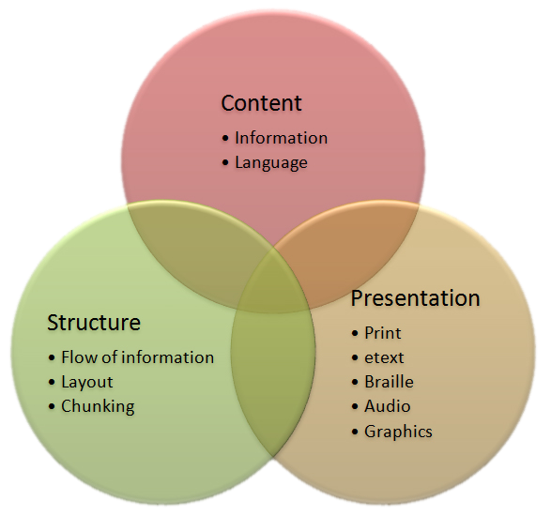
Examples of individuals who may be included in making decisions about accessible instructional materials are provided below.
- For students with a physical disability, a physical therapist, occupational therapist, teacher, and/or assistive technology specialist may work together to identify appropriate digital books and computer switch control systems and/or alternative keyboards.
- For students with autism spectrum disorder, a learning disability, or an intellectual disability, a teacher, learning resource specialist, and assistive technology specialist may work together to identify appropriate digital books and related accommodations, such as text-to-speech tools to read the books aloud, graphic-enhanced text, etc.
- For students with a sensory disability (e.g., vision, hearing), a teacher of the visually impaired and/or teacher of students who are deaf/hard-of-hearing, learning resource specialist, assistive technology specialist, and medical professional may work together to identify the appropriate format, such as braille, large print, audio, captioning, etc.
As noted in the examples above, it is important to identify any assistive technologies that may be needed to support the use of various formats or to ensure that needed accommodations are available.
Student Considerations
Natalie requires large print. A teacher of the visually impaired and an assistive technology specialist may work together to identify ways to provide large print in printed text as well as when Natalie is using a computer and when she is doing research on the Internet. Magnification devices and screen magnification may be tried. Consultations with a medical professional should be on-going due to the degeneration of Natalie’s vision.

Jesse’s reading comprehension with printed text is several years below grade level. A learning resource specialist and an assistive technology specialist may work together to assess the impact of a variety of tools and accommodations that can be used for digital text, taking into consideration the types of cognitive processing problems a student with a specific learning disability may have.
Pick at least one of the following:
Read
Put link in here (I’ll provide the link- David, ENT pages 27-28)
Students with specific learning disabilities may have a variety of processing problems that affect reading comprehension. Here are some problems and accommodations to consider.
Watch
Put link in here (I’ll provide the link – David)
Demonstration of Read and Write Gold features that can be used to support reading comprehension.
Explore
Put link in here (I’ll provide the link- David, ENT pages 16-20)
Explore some of the resources for content, structure, and presentation listed in the Exploring New Territories booklet. Can you use some of these resources with your students?

Section 3 con’t
The Role of Universal Design for Learning and AIM
Universal design as used in IDEA is based on the definition found in the Assistive Technology Act of 1998 (Section 3(17)):
The term “universal design” means a concept or philosophy for designing and delivering products and services that are usable by people with the widest possible range of functional capabilities, which include products and services that are directly accessible (without requiring assistive technologies) and products and services that are interoperable with assistive technologies.
Universal Design for Learning, or UDL, provides a framework that schools can use to identify products, services, and technologies that may assist in quick adaptations of instructional materials to meet a student’s unique needs. For example, use software to quickly change the size of digital text, provide text-to-speech tools so the text can be read aloud, provide tools to restructure the text, and (depending on the program) open a variety of text formats, including Digital Accessible Information System (DAISY), National Instructional Materials Accessibility Standard (NIMAS), PDF, text, and web pages. Tools of this nature address a wide variety of accessibility needs.
In another example, a classroom or media center may have a wide variety of books on core curriculum topics available at various reading levels, print or audio files, and regular and large print. In this way, students can quickly find the instructional materials that meet their needs.
Student Considerations
Natalie needs large print and may need magnification devices and computer screen magnification. Computers in the classroom and media center can be set so Natalie can easily enlarge the fonts as needed and then return the fonts to the original setting when she is finished. This will enable her to use the same computers other students use. It is important, when possible, to ensure that students have the ability to independently adjust or adapt instructional materials to meet their needs.

Jesse has been successfully using text-to-speech with digital books to access grade level instructional materials. Text-to-speech software utilities have been installed on the computers in the classroom as well as on computers in the media center, enabling Jesse to use the accommodations he needs on the same computers other students use.
Pick at least one of the following:
Read
Put link here (I will provide, David, ENT 10-11)
Universal Access includes a variety of assistive technologies that can be used to help make computers and digital information accessible to a highly diverse population.
Watch
http://www.youtube.com/watch?v=3Hk3sLfrtrU&feature=related
Demonstration of how a writing support software, WordQ, can also be used as a text-to-speech accommodation.
Explore
http://udleditions.cast.org/
These online UDL edition books include a lot of accommodations for accessibility. Pick one of these books and explore the different available tools to help with reading. Could you use any of these with your students?

Section 4 Final Activity
For each of the accommodations listed below, put a check “Content,” “Structure,” or “Presentation” to note which category that accommodation falls under. FCIM – the correct answers are included on this form. When the participant clicks on the “Check” button the wrong answers should be highlighted with a note to correct those answers. When all of the answers are correct they should get a “Great Job” or something to that effect.
 | Content | Structure | Presentation
Computer screen magnification |  |  | X
Highlighted key words or main ideas |  | X
Digital text with structural cues |  | X
Recorded books |  |  | X
Leveled books | X
Portable text scanning device |  |  | X
Sign language | X
Books in Spanish | X
Check

