Technology Module
Unit 3 - Section 5
Assistive Technology
Checkup: Assessment Task:

Required Activity:
Complete the following activity by dragging the parts of the SETT Framework to the Rectangle.
When the participant drops the Correct responses into the rectangle they will go to positions in picture below. The only exception is Tools –if it wasn’t the last part brought over I’d like them to get the response: “not yet, what should you consider first?”

Task
Talents
Needs
Physical Barriers
Environments
Student
Tools
Home
School

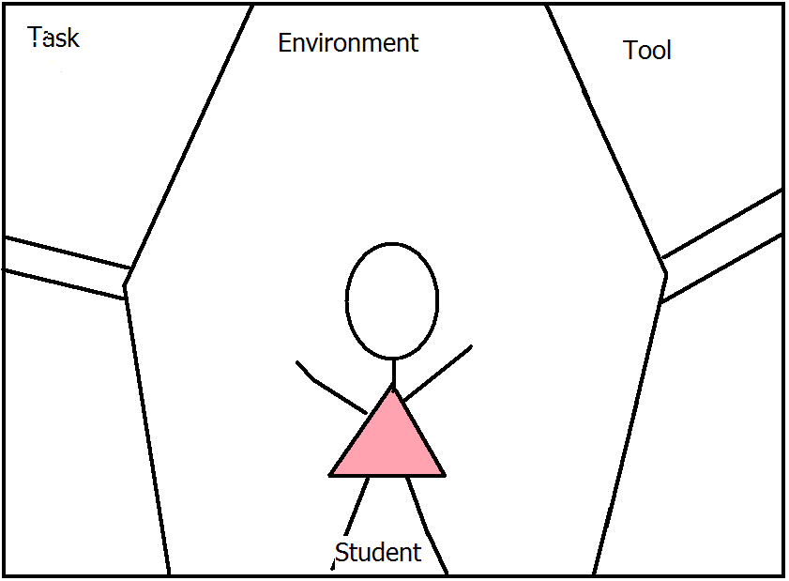
Once all of the correct parts are there place then Perhaps have the curtains open and close & some type of sound – getting started –maybe band warming up?
The final act of this activity is for you to take the phrases provided and drag them to the part of the SETT they would belong to.
Below are the phrases and in the correct place. I’d like the phrases spread around, out of order so that the participant can easily drag them to the desired place on the stage.
Student | Environment | Tasks | Tools
She is blind. | She has a Braille note taker at home. | She needs to read a book of her choice | Have voice over features placed on all computers she uses (home & school).
She can read Braille books. | She has a computer at home. | She needs to write a report about the book that will persuade peers to read the book. | Have access to bookshare or similar website so that she can download the book of her choosing.
She loves to listen to audio books. | She has her text books provided in Braille |  | Have JAWS or similar product loaded to her computers and have time to learn how to use them.
She can type using a Braille notetaker | It takes a long time to order a Braille book to read.
She’s beginning to use the computer to type using the voice over feature on her laptop. | The classroom has several computers with headsets
She is very worried about not fitting in with her classmates | The vision consultant teacher is with her first thing in the AM, but not during English.
She HATES having an assistant near her all of the time | Many of the other students in the classroom are nervous about talking to her
 | She has a seeing eye dog with her at school

When the participant takes them to the incorrect place the phrases will go back to where they were before. When the participant takes them to the correct area then color will gradually start filling in. When all of the parts have been done correctly the “student” will dance or sing & then have the sound of applause.
Now, you have the tools to “SETT” the stage for your students’ success!

