Technology Module
Unit 3 - Section 1
Assistive Technology Introduction
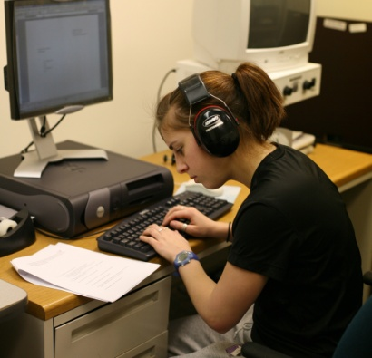
Welcome to Unit 3 of the Technology module. This unit will explore Assistive Technology (AT) in K-12 education. AT can level the playing field for students with disabilities in public schools and allow them to participate fully in public education. AT was legally introduced to special education in Public Law 101-476 or the Education of the Handicapped Act Amendments of 1990 which from that time to the present is known as The Individuals with Disabilities Education Acts (IDEA). http://www.unc.edu/~ahowell/exceplaw.html
This unit will introduce you to assistive technology devices, services, and frameworks to ensure that you and your team are helping your students with disabilities to be successful and comply with the legal mandates from IDEA.
Listed below are the objectives that will be covered in this unit.
Objectives:
- Define Assistive Technology Devices
- Define Assistive Technology Services
- Align various assistive technologies with student needs
Before we get started let’s meet two 7th grade students at Tech Town Middle School from Mrs. Techni Challenged’s 7th great English class. Mrs. Challenged is have a great deal of trouble helping these two students participate in her writing assignment. Her classroom is physically accessible and meets the students ‘needs. Mrs. Challenged has classroom ten laptop computers that have a suite of software programs that provide text to speech, word prediction, and a talking word processing program. We will follow them through the AT process and see if we might be able to help out.
 | Meet Jesse  He is 13 years old (he was retained in first grade). He attends all general education classes and receives special education services of learning disability inclusive support, occupational therapy, and resource learning disability support for a study skills class.  He has significant reading deficits and currently reads on a second grade level. He has an active IEP, which many accommodations including the ability to have access to digital text versions of his textbooks.
 | Meet Tea’  She is a 13 year old, 7th grader attending Tech Town Middle School. She attends all general education classes and receives special education services of orthopedically impaired inclusive support, speech and language therapy, occupational therapy, physical therapy, and adapted PE.  Tea’ is very bright & friendly. She cannot verbalize so she uses a voice output device to communicate and a power wheelchair to get around the school. Tea’ has a special education paraprofessional that helps her with physical access issues (in the bathroom, lunch, opening doors, etc.)  While Tea’ has grade level reading & above average writing skills she needs help to manipulate books, paper, etc. She prefers to do as many things independently as possible.
The pictures above are from a Bing search. Feel to replace them. The first should be of a 13 year old boy and the second a 13 year old girl in a wheelchair.
Before getting started, take a moment to complete “Section 2, Where Are You Now?”.

