Chronic Absenteeism Guiding Questions
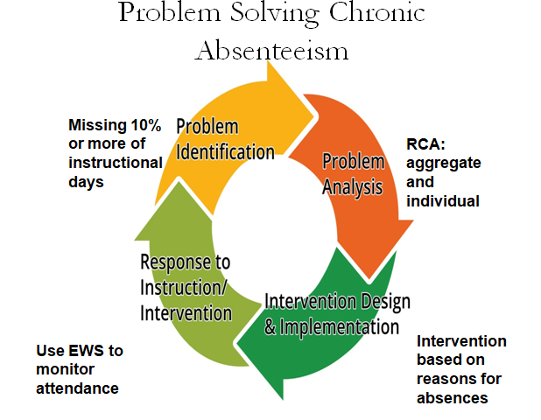
- What is the percentage of students with 95% or better attendance?
  - School-wide
  - Grade-level
  - Subgroup
- What is the percentage of students missing 10% or more of instructional days overall?
- What is the percentage of SWD missing 10% or more of instructional days?
  - What is the percentage of economically disadvantaged SWD who are missing 10% or more of instructional days?
  - What is the percentage of male SWD missing 10% or more of instructional days?
  - What is the percentage of female SWD missing 10% or more of instructional days?
  - What is the percentage of each racial/ethnic group who are SWD missing 10% or more instructional days?
    - White
    - Black/African American
    - Hispanic/Latino
    - Multiracial
    - Asian
    - American Indian
  - What is the percentage of SWD missing 10% or more instructional days by disability category:
    - LD
    - EBD
    - InD
    - OHI
    - SLI
    - Other categories
- What are the reasons SWD are missing 10% or more instructional days?
- What are potential next steps for addressing attendance/chronic absenteeism in your setting?
  - Building awareness and messaging?
  - Creating a culture of attendance?
    - Recognitions/celebrations
  - Data collections- surveys, focus group, etc?
  - Partnerships?

